SECOND 2021 QUARTERLY MEETING OF KITTAMAQUNDI COMMUNITY, INC.
Sunday, June 27, 2021, 1:00 pm via Zoom
President Ellen King’s Report and Council Update
Council President, Ellen King, opened the meeting with prayer, and presented her President's Report for the Second Quarter of 2021 (see President's Report attached.)
Don Link reported for the Financial Leadership Team. Figures were available through May, and Don cited KC's current good financial position using Power Point charts and his always clear explanations of income versus expenses, and budget projection numbers versus real expenditures. (See attached PowerPoint printout of the slides Don presented.) He noted that the temporary Corporate Mission set up to receive funds in memory of Wayne Ivester for KC's HCC Scholarship Endowment Fund was set up and has started to receive checks. He let us know that Building & Grounds Leadership Team is embarking on a new project to upgrade and enhance the Fire and Safety equipment and procedures for the building per the Howard County rules. The project is in its early stages, and funding will be made available for it through the BGLT Reserve funds and other savings accounts as necessary.
Theresa Gale reported for the Worship Leadership Team. KC has begun to emerge from the pandemic quarantine by offering limited in-person worship again, along with continuing the Zoom streaming experience. There have been 3 good live worship Sundays, but she cautioned that the tech crew and the Worship Task Groups are still learning how to maneuver through this re-opening. She asked for patience from worshippers as we find our way forward, and also requested feedback from worshippers' experiences so the process can continue to improve. While Claire is away for her Renewal Time, the Worship Task Group for July will be the Genesis Care Group, facilitated by Amy Sens.
Don Link gave the re-naming report, presenting an explanation of the process of ranked-choice voting. These slides are also an attachment.
Normale Doyle reported for the Community Life Leadership Team and asked if any additional worshippers would prayerfully consider joining the team. There is much to be done, and she has specific projects ready for a willing volunteer.
Ken Katzen reported for Vitality, Diversity, and Inclusion, and shared the extensive VDI list of community involvement projects. KC is becoming known throughout our community for our involvement and support in these many projects. Any who wish to take the next step towards the goal of having an external witness for justice and equity, can see attached list, and contact Ken with any questions. Upcoming in October are the PRIDE events. Claire and Juls Gilliam are spearheading, and will welcome other volunteers.
Accolades
Ellen asked if anyone present would like to commend someone with an accolade for outstanding service or presence, and the following were offered:
Normale commented on how impressed she was that 8 people happily volunteered to train for and host the KC Hospitality after the worship service. She was very grateful for their help. Now she is free to monitor the Chat function in Zoom and take note of the new people who tune in.
Ken noted that Amy Sens is beginning the Worship Consultant position, and that Kathy Marshall and Harriett Katzen are finding many challenges as they fill in for her in the KC Office for the duration.
Theresa commended Michael Cleveland for the many many hours he has dedicated to making the new tech equipment work smoothly. Don Benson added to the commendation for Michael, noting that Michael often comes in on a Saturday to figure out how to solve the various problems that still arise, and then communicates his discoveries and solutions to Austin and Don.
Ken also commended Michael for jumping in and solving a tech problem for Vicki Jenkins-Long and her family, and Sandy Q also praised Michael's tech work with Vicki and her husband's care-giver, Beth Green.
Normale commended Ellen for doing such a good job keeping in touch with Council and KC while she was traveling.
Allan Lohaus announced that BGLT will be holding a full, in-person Barn Work Day on Labor Day, 8:30 to 12 noon with lunch afterwards. Plans will be made at the end of August—everyone is welcome, as there is much to be done, at every skill level.
Normale gave the closing prayer.
Respectfully submitted,
Kathy Marshall, Council Secretary
See attachments: President's Report , VDI Community Contacts List, CLLT's Report, Treasurer’s Report, and Rank-Choice Voting for the New Building Name.
KC COMMUNITY MEETING
1:00 PM June 27, 2021
President’s Report and Council Update (Ellen King)
There have been many things for Council to consider the last three months. Let me give you a quick overview of what your Council has been up to:
BGLT held the first Barn Work Day in over a year. Many turned out and a lot of work was accomplished. The gardeners are keeping the garden looking lovely. There will be numerous opportunities for people to enjoy both the inside and outside of our building as rentals return. The calendar is filling up so, if you want to use the building at any time this year, reserve the date now! We are seeing an upswing in rentals due to everyone having to postpone from last year.
The Community Life LT’s new leader is Normale, who has been very busy working with her team. She will be talking later about the great work they are doing.
The Worship LT has been industrious throughout the pandemic and beyond. Earlier this week I announced that for now, Council has decided that masks will not be required for worship upstairs. This policy is open to change as new information about the virus is learned. We are very lucky to have Dale on Council, who keeps a diligent watch over all things COVID-19 related and keeps Council aware of things as they change.
In addition, Council voted to suspend our presence on Facebook temporarily and we are exploring our options and will discuss it during the July Council meeting. Council meetings are open meetings so if you wish to participate in the discussion, please plan to join us on July 25th at 1:00. Of course, feel free to contact anyone on the WLT or Council with your thoughts.
As you know, the Spiritual Enrichment LT had been very active during the pandemic. During the summer, with people taking vacations and being busy outside the home once again, they have decided to take the summer off and regroup in September. Ideas are brewing and they will keep us informed as they come to fruition.
Just a reminder that this year’s retreat will be Halloween weekend at KC. Saturday the 30th and then recommitment Sunday on Halloween. Sounds like fun so save the date!
Council Goals this year include updating the P&P manual as well as the by-laws. The by-law changes will go to Council in August and to a Members only meeting on October 3, 2021. As of now this will be a blended meeting, meaning both in person and via zoom. I urge all of you to attend in some manner. We must have a quorum to vote and voting by proxy does not add to the count for a quorum. Members voted on an amendment at the last community meeting, but it was invalid because a quorum was not met.
Groups have been meeting regularly to work updating the P&P manual. I am confident this goal will be met by year end. Others goals we have include implementing a central electronic retention system, to be an external visible witness for justice and equity, facilitate the work of our leadership teams and to improve Council’s communication to the community. If you have any interest in working on any of these goals, please contact me.
Council has before them a contract to renew our commitment to Rolling Ridge. It is a three-year commitment. Many of you are unfamiliar with what RR is and what it means to this community. I asked Marge Goethe, who has been a part of RR community for many years, to write a short piece on it. Let me read it here:
Rolling Ridge is one of the largest privately held wilderness preserves near Washington DC. On its 1400 acres of secluded, forested land are miles of hiking trails, the Appalachian Trail, the Shenandoah River, five mountain streams, ponds, waterfalls, and scenic overlooks.
During the 1970s 2 Quakers, the Niles family, envisioned and purchased land holdings south of Harpers Ferry to be turned into a Wilderness preserve. RR is one of 3 groups to put the vision into action. This land is nestled on the beautiful slopes of the Blue Ridge above the Shenandoah River. The founding families and their faith communities called Partner Groups met and camped regularly, eventually constructing staff residential homes, buildings, and gardens. The Retreat House was built in 1987-88 by the efforts of many (not unlike the KC barn) creating a retreat environment
KC was looking for a retreat center and, in the fall of 1989, Jerry Goethe lunched with Gordon Cosby who arranged a meeting with Paul Peachey, a professor at Catholic U. Paul excitedly told Jerry about RR and said that shares were available. KC chose to buy 8 shares (we now have 1). The first retreat was the Member to Minister group in August 1990. The second weekend was called Jesus, Jung, and a Journal—led by Charlie Powell and Jerry. For many years we usually used our weekends.
Other retreats included Questing, Learning, Reforming; God’s Creation—My Participation; Meditation Arts; Fasting, Prayer, Silence; Dreams; Birds and Plants, “Mary the Mother of God”; among others. Frank hosted an AA men’s group in the winter—some hiked in on the Appalachian Trail. The RR Community also hosted retreats we could join. We were welcomed by staff with candles, floral arrangements and a warm fire in the wood burning stove. We washed dishes by hand (many hands...) now there’s a dishwasher. Many came early on Friday and stayed until midday Sunday. Guy was the first to find the “hidden” waterfall; others hiked to views of the Shenandoah. George, Bob Kraus, Amy, Heather, Anne and others helped with upkeep on special workdays. The staff would share stories of the history of the area. Jerry, Charlie and Marge served on the Board over the years.
In recent years we have not always used our RR weekends, which is one reason we now have only one share. If Council decides to renew our contract, we would like to see that one weekend be used each year for a KC event. Marge is willing to work with others, including Sue Senate, to come up with a few ideas for making RR more known. Please contact Marge if you are willing to help with that effort.
And lastly I want to announce the new name of our building. You have all been waiting patiently for this. The building will now be called The Carriage House. Don Link will explain later, in our agenda, how the votes were calculated. I want to thank Don Link, Annora Bailey and Rebecca Dietz for all the work they put in for the renaming of our building.
I also want to thank all Council members, as well as Don Benson, Bonnie Orrison, Anne Yenchko, and Theresa Gale for their attendance at more than one Council meeting lending their support to Council and to all the Council Leadership teams who are working so hard this year. It has not been easy these last 18 months, but I am very inspired as I watch us all pull together to support each other and the church as a whole.

VDI COMMUNITY CONTACTS, May 2021
Council Goal: Externally visible witness for justice and equity
In addition to contributions by the outreach team and activities of individuals in KC we are actively witnessing for justice and equity alongside these Howard County organizations this year:
  - Town Center Village Board
    - Ongoing communication
    - Liaison with Town Center Little Free Pantry (JoD)
  - HoCo Center for African-American Culture
    - General Support
    - Juneteenth 2021 - Ken is on the planning team and panel (Claire will be out of town)
  - HoCo NAACP
    - Building use
    - Participation
  - HoCo Lynching Truth & Reconciliation
    - General Support
    - Information sharing
  - Running Brook Elementary School
    - Various projects. Will go into higher gear in Sept; Claire is liaison
  - St. John United Methodist-Presbyterian Church
  - Howard County Library
    - Participation in Juneteenth 2019
    - Coordination with HCPL equity activities
  - Howard County Office of Human Rights
    - Co-facilitation
    - Planning
  - Howard County General Hospital
    - Covid screening site
  - Courageous Conversations
    - Advisory team
    - Facilitation, participation
  - PATH
    - Participation
  - HoCoPublic School System
    - Student groups: support, facilitation (Rebecca, Ken. This is Rebecca’s project.
  - HoCo Pride Festival (Coming Oct 2021)
  - Research Associates for the Name Them project
    - Howard County Archives/Howard County Historical Society
    - MD State Archives
    - Wilde Lake High School researcher
    - HoCo Lynching Truth & Reconciliation
    - Columbia Archives
    - HoCo Center for African-American Culture
    - Individual researchers in the community
Questions? Contact Ken Katzen kkatzen01@gmail.com.

Normale Doyle's Community Life Leadership Team Report, June 2021
I’d like to tell you a little about the Community Life Leadership Team because we are ready to welcome you to be part of our Team.
Some of the things ComLife does are:
We promote, support, and encourage ideas that require the time, talents, and energy of the community and are not exclusively supported by another leadership team.
We encourage full inclusion of everyone in the KC community, and seek to expand inclusion of underrepresented groups.
We make new people feel welcomed.
We maintain contact with visitors and those ceasing to be part of the KC community
We organize Zoom Hospitality
We oversee KC Focus Groups and Care Groups and the KC Membership process.
We are looking for someone to be a shepherd. We have a good system worked out to stay in touch with new people, but where we are weak is in shepherding existing people. We would like someone who would focus on people who have been away for a while and are returning. We want those folks to feel welcomed back, and also the people who have been part of us and are no longer connected. We want those folks to know we noticed they are missing.
To do this job you need to have a memory for people so you can notice their comings and goings, or you could use the snapshots of the services I create to track the people.
I am hoping someone will join us who is feeling called to shepherding these people.
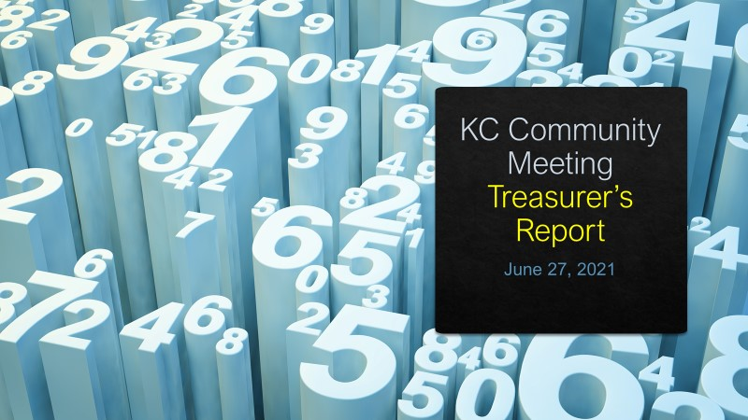
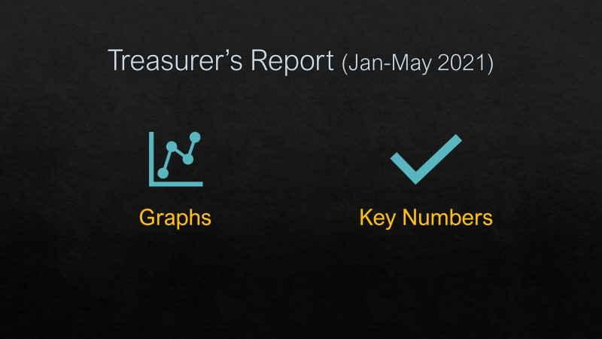
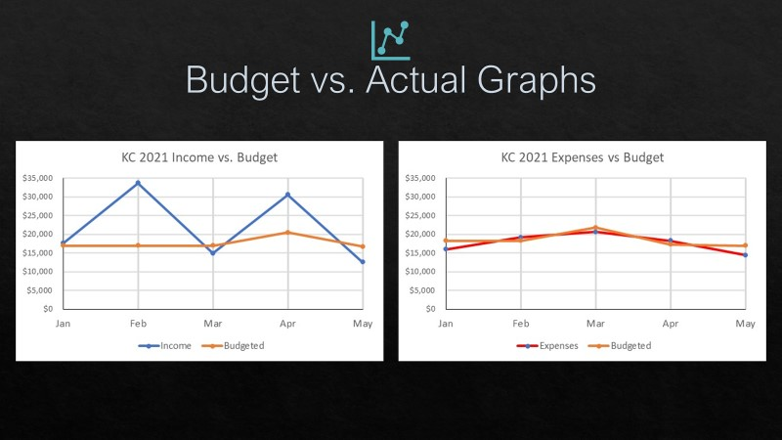
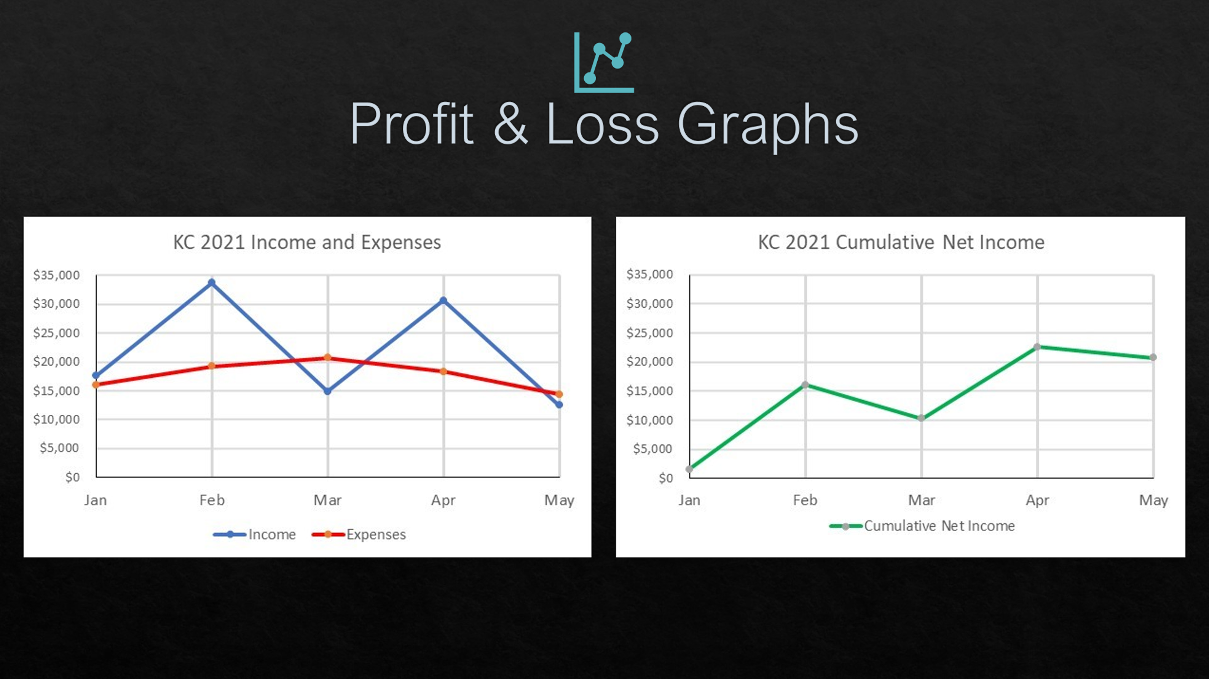

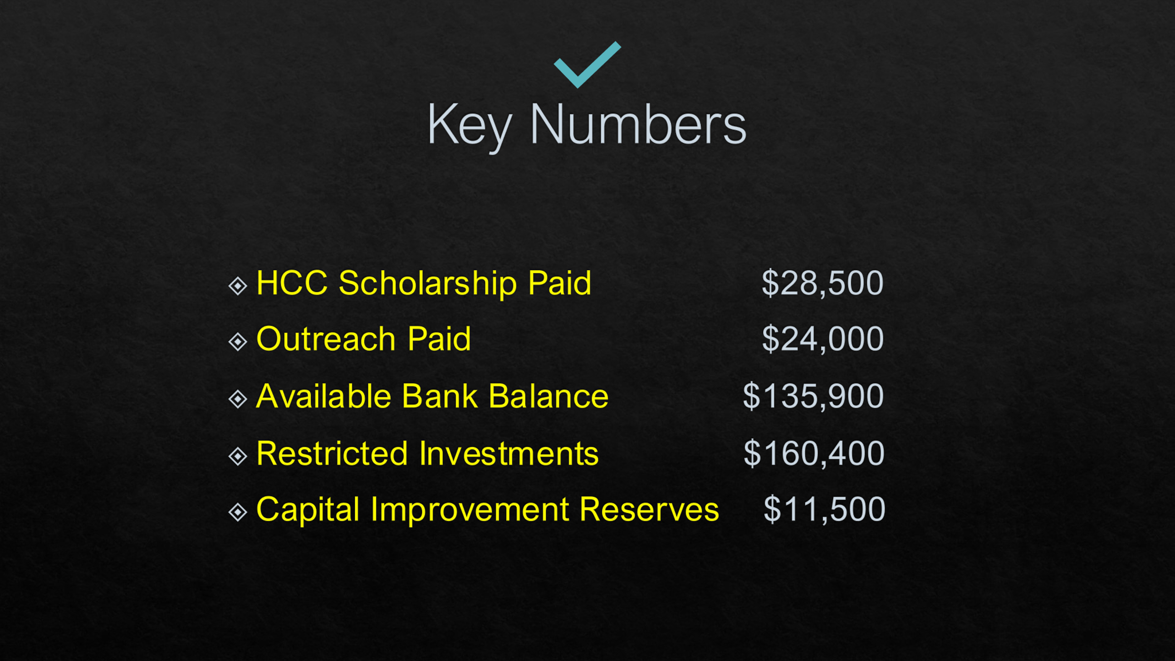

Rank-Choice Voting for the New Building Name

